- Install the Software
  - Download the compressed folder (*.zip) which contains the software installation executable (link here).
  - Extract (unzip) the compressed folder to access the executable.
  - Launch the executable, ve2022setup_fbc_supplement.exe.
  - Follow the instructions through the installation.
- Weather file
  - Download the Orlando TMY3 (*.epw) weather file in the compressed folder (link here).
  - Extract (unzip) the compressed folder to access the weather file.
  - Place (copy and paste) the file (USA_FL_Orlando.Intl.AP.722050_TMY3.epw) in the default directory (or whatever directory the software was installed), C:\Program Files\IES\Shared Content\Weather (admin privileges needed)
- Open and Register the Software
  - From the Windows Start key, search “Virtual” and select/open Virtual Environment 2022. This should also be located C:\Program Files\IES\VE 2022\apps\VE.exe
  - Close the IESVE Start Page (or hit the ‘esc’ key) to open the software
  - Go to the Help Request License Keys IES Software Registration Procedure
    - Fill out the information completely.
    - Select ‘Request License Key’ from the drop-down menu, and click ‘Send Request’… If this doesn’t work, or if the user has previously taken an IESVE trial, please email IESVE Staff for a license key.
    - Copy the license key from email and paste it in the value field.
    - Select ‘Activate Software’ or ‘Activate Free Trial’, and click ‘Send Request’. This should activate the software and all applications and navigators for the user.
- Download and Open the Example Project
  - Download the compressed folder (*.zip) which contains the project file (link here).
  - Extract (unzip) the compressed folder to access the project archive (*.cab) file; remember the location of this Florida Supplement 2022 Project.cab file.
  - In IESVE, go to File Archive Extract
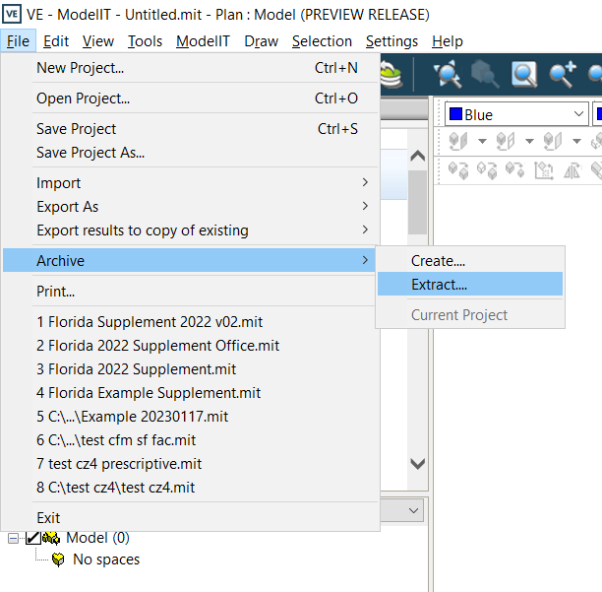
  - Find the Florida Supplement 2022 Project.cab file and extract to a convenient location. When open, there is a copy of the updated Florida Compliance Report with 2022 Supplement that is already generated in the Content Manager (Tools Content Manager). Users can also go through the process of compliance simulation with the guide of the Upskill with IES Video (link here).
If you have any questions about installing, downloading, or reviewing, please feel free to reach out to the contact information below.

Sincerely,
Matthew Duffy

 | Matthew Duffy (he/him/his)  VP IESVE Sales North America East | C: +1 415 420 9314  E: matthew.duffy@iesve.com  http://www.iesve.com

